Queenscliffe
and District Neighbourhood House
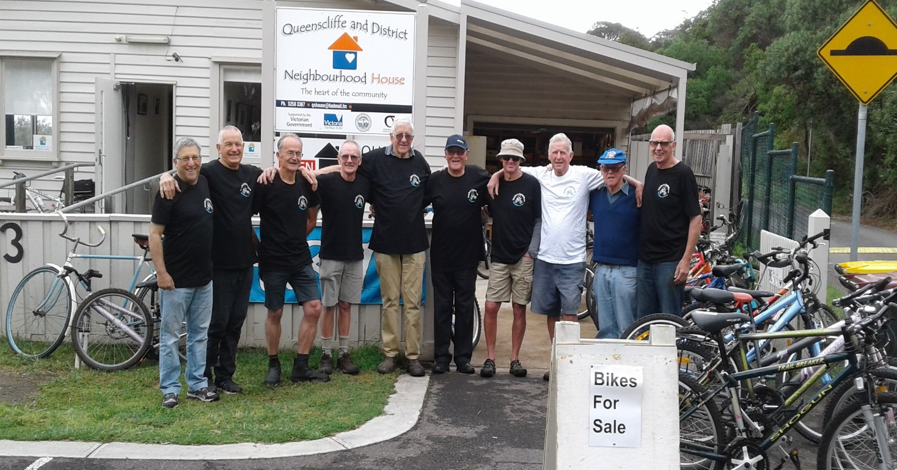

Annual Report 2018

Queenscliffe and District Neighbourhood House
Inc. No. A0009668N ABN: 65 700 715 581
3 Tobin Drive Queenscliff 3225
Phone: 5258 3367
qnhouse@fastmail.fm
www.qnhouse.com.au

Committee of Management
Chairperson
Jacinta Farrugia
Vice Chairperson
Laurie Muscat
Treasurer
Roel Wasterval
Secretary
Diana Sullivan
General Members
Sue White
Simone Knott
Paul Jones
Co-ordinators
Carolyn Williams and Jane Rodwell
Aims
- To foster a spirit of unity within the community.
- To provide a centre for activities that will meet the needs of a wide range of community groups.
- To encourage the community to take an active part in organising and implementing activities.
- To create a neighbourhood network as a focal point for exchange and interaction between groups and individuals at the local level.
- To provide support and scope for personal enrichment and involvement for people of all ages and backgrounds.

Chairperson’s Report

The past year has seen outstanding growth at the Queenscliffe Neighbourhood House. This year we have built on a solid financial foundation and with an enthusiastic Committee of Management we have started to embark on implementing the first stage of our 3year strategic plan. This plan has helped to drive our Committee activities and ensure we keep up to date and moving forward. As a result, we have restructured our sub committees to ensure we are meeting our milestones. These include: Governance, Infrastructure and Environment, Finance and Special Projects.

To ensure we have the right mix of skills on our committee and in line with our strategic plan, we conducted a skills audit of our current members. This not only helped to highlight the skills of our existing committee but also identified skills needed to recruit new committee members. We welcomed Simone Knott and Paul Jones to our new committee both of whom bring a range of new skills and ideas.

We were also fortunate to have our coordinator position funded for an extra five hours by The Department of Health & Human Services. This has allowed us to employ Carolyn for an extra 5 hours and Jane Rodwell for 3 which means we now have a coordinator in the office on a Friday morning. Jane has also been responsible for the very successful Boomerang Bag project which not only helps to foster sustainable behaviour but also raises the profile of QNH. Our wide range of fee-for-service programs and interest group participation have gone from strength to strength. So much so that QNH is now running out of room to accommodate the demand for community needs. This is a great problem to have and for our committee to address in 2019.

As part of our 3-year strategic plan we also have embarked on a Community Needs Assessment which has been funded by QNH. The initial outline for the needs assessment was scoped out by Anne Horsley. Rose Ott has been employed to implement the Community Needs Assessment and I would like to acknowledge the great work that both Rose and Anne have contributed so far to the project. This is an exciting chapter in QNH history as the data from this assessment will enable us to build on our strengths and also identify future opportunities for this organisation.

For those who are social media savvy you would have noticed we now have a new website which has been set up voluntarily by Paul Jones and Jane Rodwell. This website is easy to navigate and allows us to make our own changes and we thank Paul and Jane for their involvement.

We said farewell to committee member, Kath Lang, who has been a tireless worker over the years contributing greatly to the promotion and fundraising within our organisation.

In building assets, we have received generous funding from the BOQ to contribute towards building a new deck. Our Infrastructure Committee has worked closely with our Borough engineer in the planning stages. Our Governance Committee continues to look at and update policies and other governance related issues. Our Finance Committee continue to provide transparent and accurate financial records. We have been very fortunate to have Sue White for the past two years as an honorary book keeper. Sue has streamlined and improved our financial reporting systems and has also suggested changing our financial year to coincide with a calendar year which makes it easier to keep track of our finances. Sue is stepping down from this role but fortunately will still remain on the committee. We would like to thank her for her wonderful contributions over the two years she has held this position.

I would like to recognise a number of people and organisations for their ongoing support. This includes: our wonderful tutors and to all the participants who have attended either a QNH program or have been part of the many interest groups which are associated with the House. I would also like to acknowledge the Queenscliffe Borough Council, the numerous local agencies and community organisations for their ongoing support. A big thanks to our hard working Committee of Management and volunteers for their diligence, commitment and willingness to do whatever is needed.

To our wonderful QNH coordinator Carolyn and her assistant Jane you bring this all together so it looks effortless. Thank you so much for your dedication in making our House such a wonderful place to be for all our community.

Jacinta Farrugia
Our Committee of Management
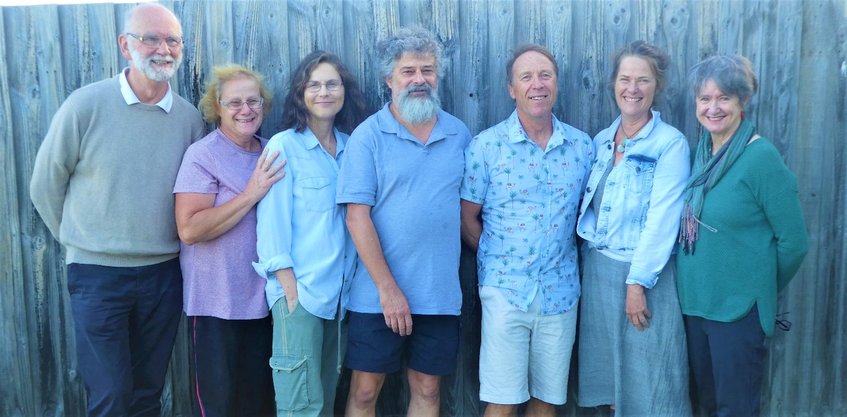
Roel, Diana, Sue, Laurie, Paul, Simone and Jacinta

Co-ordinator’s Report
2018 was a very busy year for Queenscliffe Neighbourhood House. We established several new partnerships with other organisations, welcomed new committee members, expanded our Art Program, initiated infrastructure projects and developed a process for our Community Needs Assessment.
In reaching out to other organisations we:
- Supported the development of Transition Towns Queenscliff and piloted a Repair Café
- Supported the inaugural Low Light Festival which included organising weekend Art Workshops for their Program
- Partnered with Ocean Grove Community Hub to run a Responsible Serving of Alcohol course
- Supported the Queenscliff Kindergarten initiative by becoming a collection point for dental hygiene products which are recycled and turned into new items such as outdoor furniture
- Initiated a new annual Primary School Art Exhibition for the month of September with support from the 3 local schools
- Supported Rural Australians for Refugees by becoming a collection point for their Asylum Seeker Foodbank
We continued our involvement with other organisations including:
- The Literary Festival in providing space for meetings and workshops
- Bellarine Arts Trail by being one of Queenscliff’s venues, highlighting work from our local artists
- Borough of Queenscliffe by collecting disused batteries for safe disposal
- Corio Lions Club Road Home Project in collecting winter coats and blankets for the homeless
- Love Your Sister cancer research charity with over $260 raised through coin donations
- Australian Hearing to provide Free Hearing Tests
- Campbell Paige to offer a weekly employment service
We are extremely proud of the Men’s Shed Bicycle Repair Group (see photo on front cover of this report). They have donated hundreds of bikes to African communities through the Bicycles for Humanity Program as well as raise funds to support refugee camps in Queenscliff.
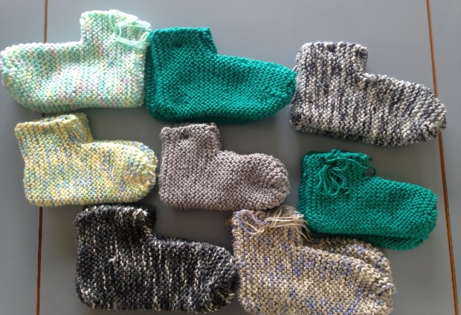
Our Mixed Craft Group continue to knit garments for Cottage by the Sea, Geelong Mums and Refugees Aid as well as the Royal Flying Doctor Service:
Slippers for the children who are offered beach holidays at Cottage by The Sea. All children go home with slippers, a beanie and a rug.

Beanies are shared between Cottage by the Sea, Geelong Mums and refugee groups
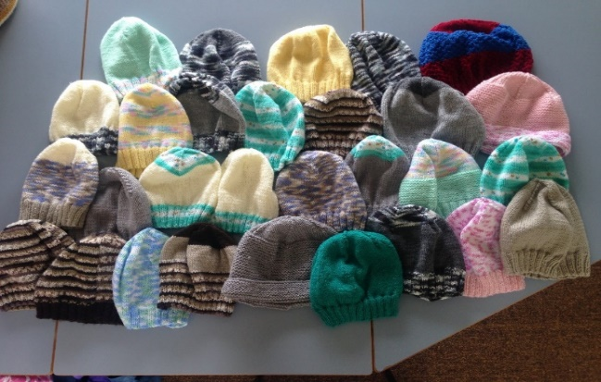

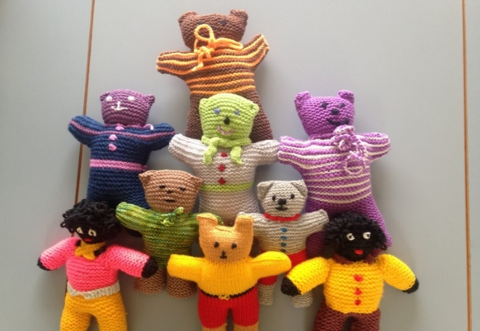
Soft toys for the Royal Flying Doctor Service; one of the knitters has family in the service and they send them all to him.

In 2018 we embarked on new infrastructure projects:
- Negotiated joint funding for a new deck area with the Borough of Queenscliffe
- Purchased new shelving for the store room to enable more efficient storage of class and interest group materials
- Installed picture rails throughout the House to enable more artwork to be displayed.
Our Community Education Program depends on the time and effort of the tutors. Some of these tutors volunteer their time completely, others volunteer their preparation and travel time and are paid at a “community rate”. We thank all our tutors for their efforts and the high quality of their teaching.
Andrea Robertson Tides of Welcome Community Choir
Anita Armytage Collage Workshop
Bruce Sherriff Yoga
Chris Gould Painting Together, Paper Craft Creations for
Christmas, Hand Stitched Books

Jane Rodwell and Jenny Gore Play Ukulele
Lesley Hughes Yoga
Louise Stanley Italian & French
Monica Heathcote Crochet
Matthew Ponsford Defibrillator Demonstration
Paul Jones Apple Mac, iPad and iPhone courses
Ryan Brearley Art classes
Shane O Cleirigh Yoga
Silvana Benacchio Mandala Writing
Scheduling of classes is always a challenge. To enable more people to attend we have run evening Art classes as well as weekend workshops including several over the January holiday period.
Our Sea of Ukes Ukulele Classes are extremely popular. In responding to the huge interest in getting together to sing and play, Ukes on Tap was organized at the Queenscliff Brewhouse. Held every 2 months it attracts up to 100 players from all over the Bellarine. Jane Rodwell and Jenny Gore have been integral in the group’s success.
Our Art Program has continued to grow with Ryan introducing and developing a range of courses that build on skills participants have gained, whilst welcoming newcomers to the world of Art. Many people have discovered talents they didn’t know they had in these warm and welcoming classes:
- Painting Basics
- Beginning to See and Draw
- Continuing to See and Draw – day and evening classes
- Drawing Towards Paint
- Painting Still Life in Oils or Acrylics
- Beginning to Paint Using Watercolour and Gouache
- Painting the Landscape en plein air and studio based
- Painting the Portrait
- Journaling Your Art Practice
- Colour Fundamentals
- More Colour
- Printmaking
- Coloured Linocuts

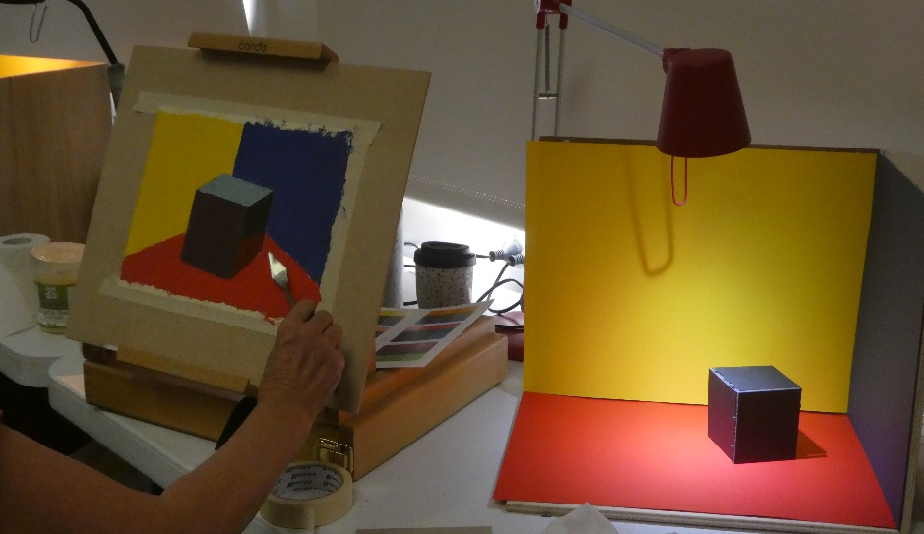
Colour Exercises in Painting Classes

Volunteers
The Neighbourhood House relies heavily on the support of volunteers, whose efforts are highly valued and greatly appreciated.
Office Volunteers:
Trish Miller Leonie Anderson Jo Fearon Tracy Watt Christine Comiskey Sandra Kent Vicki Green Faye Munroe Lorraine MacDonald
Finances
Jane Rodwell
Sue White
Roel Wasterval

Computer Maintenance
Laurie Muscat

Front Garden Beds
Simone Knott and Paul Clydesdale
Back Garden
Men’s Shed

House Gallery Committee members
Ryan Brearley
Cath McCall
Helen Stillwell
Sue White

Community Garden Committee Members
Noell Roob
Ralph Roob
Chris Cherry

Tides of Welcome Committee Members
Paul Jones
Deb Lockie
Alastair McCallum
Rose Ott
Carolyn Williams

Boomerang Bags
Wendy, Lyn, Deb, Gail, Janine, Judy, Pamela, Rhonda, Sheri, Suzie, Zoe, Sharon and Cathy
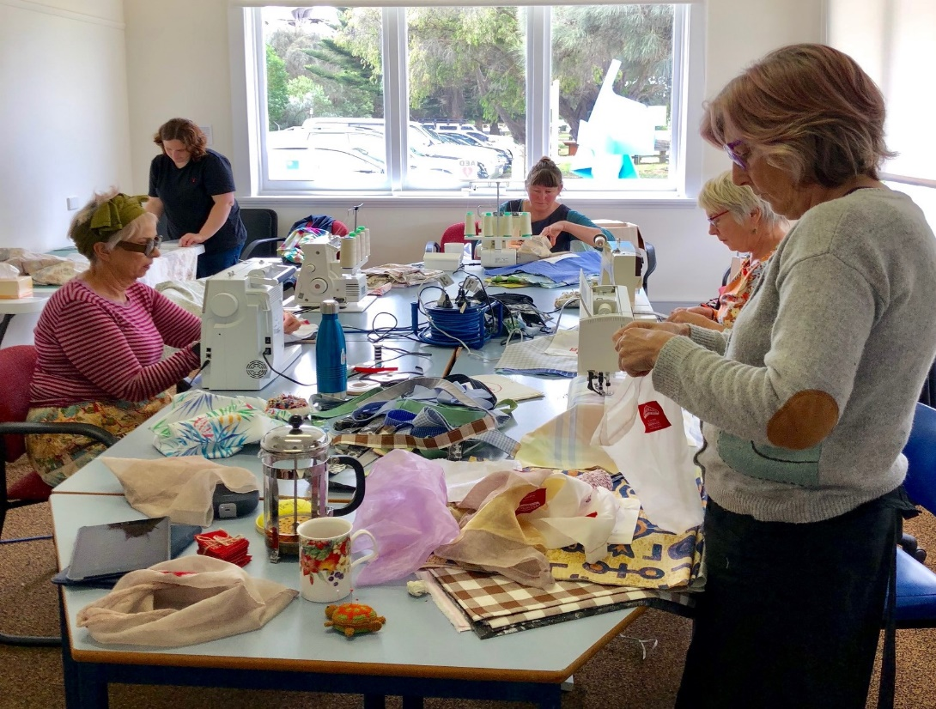
Boomerang Bag Makers at Work

Our Interest Group Convenors:
- Book Group: Celia Brown
- Bookmaking Group: Susie Del Papa
- Boomerang Bags: Jane Rodwell
- Friday Painters: Jo Fearon
- Life Drawing: Shirley Hurley and Gail Martin
- Mahjong: Gail Stocker
- Men’s Shed: John Goodman, Ron North
- Mixed Craft Group: Sue Smith
- Patchwork Network: Gayle Harrell
- Photographic Group: Jim Thyer
- Stitchers at Sea: Meralyn Roberts
- Tides of Welcome Choir: Carolyn Williams
- Writer’s Group: Denise Main
We also rely on the support of volunteers to organise and run our annual Sand Sculpture Contest:
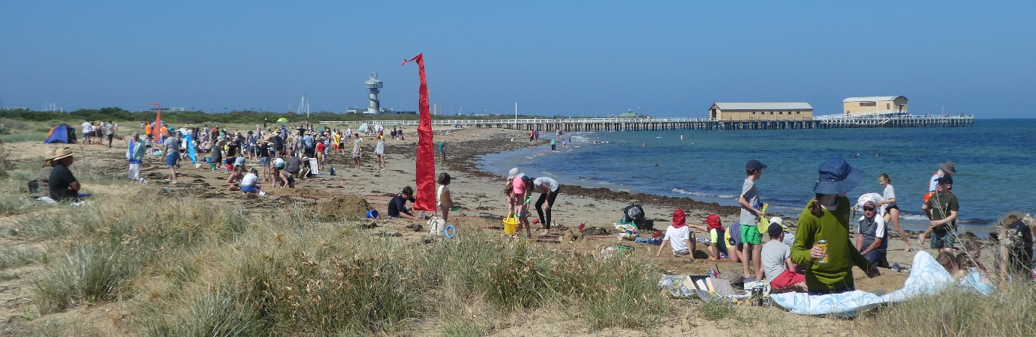2018 Sand Sculpture Contest Judges:
David Jarman, Chris Box, Lyn Pring, Robyn Veleff and Peta Bigum
Fundraising and Event Support:
Vicki Green, Paul Jones, Dennis Farrugia, Roel Wasterval, Sue White, Jacinta Farrugia, Janelle Jenkins, Anne Horsley, Jane Rodwell, Kathy Lang, Felicity McKenzie, Neil Clowes, Tony Cook and the Men’s Shed team, Laurie Muscat, Lillian Van Laars, Diana Sullivan and Jeff Cooper
This event is also widely supported by local businesses:

2018 Sand Sculpture Contest Sponsors:
- Queenscliff Bowling Tennis & Croquet Club
- Fletcher’s Real Estate
- Kerley’s Real Estate
- QPLCE (Queenscliff Point Lonsdale Community Enterprise)

Prize Donors
- Marine Discovery Centre
- Queenscliff Maritime Museum
- Queenscliff IGA
- Sea Road Ferries
- Lix Ice-Cream
- Queenscliff Bowling, Croquet & Tennis Club
- TJ Amusements
- Bellarine Railway
- Lonsdale Tomato Farm
- Pt Lonsdale Tennis Club
- Pardey’s Chemist

In-kind media sponsors:
- Queenscliff Herald
- The Rip
- The echo
- The Bellarine Times
- Geelong Advertiser

Financial Support
We remain grateful to the Victorian State Government in providing 25 hours Co-ordination funding through the Department of Health and Human Services.
Other funds received include:
$1240 from Borough of Queenscliffe for folding partition/room divider for display of art work, particularly the Primary Colours of the Borough Exhibition. This has also enable us to divide the middle room to create an extra meeting space.

$ 500 Queenscliffe Point Lonsdale Community Enterprise for Mixed Craft Group Knitting wool and $1800 for Community Garden Greenhouse

I feel extremely privileged to co-ordinate these programs and activities and greatly appreciate the support of the Committee of Management, volunteers, tutors and community members. I look forward to the year ahead as we work together analysing the results of our Community Needs Assessment and in doing so further establish Queenscliffe Neighbourhood House as a vibrant and integral organisation in the local community.
Carolyn Williams
Boomerang Bags Report
Queenscliffe Neighbourhood House received a Community Environment Alliance Grant from BOQ in June 2018 for $2000 to set up the Boomerang Bags Project in Queenscliff and Point Lonsdale.
Implementation of the project has included:
- Liaison with the Boomerang Bags organisation
- Sewing and screen printing equipment purchased
- Promotion of the project to attract volunteers and fabric donations
- Making days commenced early August on Friday mornings and Saturdays with the Repair Cafe
- Men’s shed made 2 stands for IGA Queenscliff and Point Lonsdale
- Official launch at the Point Lonsdale market on Sunday Dec 9
Media coverage has included:
- Borough Bites
- The Rip
- Queenscliffe Herald
- QNH Newsletters
- Socail Media – Facebook, Instagram, QNH website
To date, volunteers have made over 300 Boomerang Bags (in the first 6 months) which is a great effort.
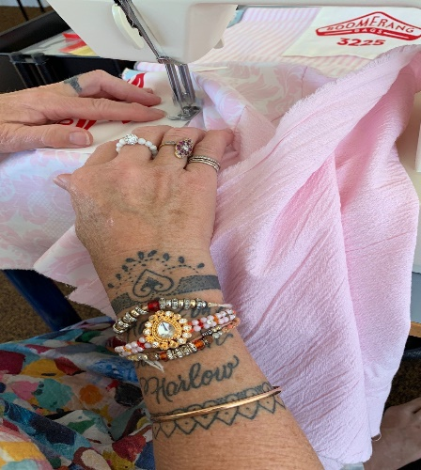

Jane Rodwell

REPORT FROM THE QUEENSCLIFF COMMUNITY GARDEN SUBCOMMITTEE: Chris, Noelle & Ralph
In spite of the lack of rain the community garden continues to produce tomatoes, radishes, radicchio, sunflowers, beans, beet root, peppers, rocket, eggplant, limes, 3 types of peas, sunflowers, potatoes, coriander, pumpkin, sweet corn, kale and lots of herbs. Some plants from seed and others from seedlings. The raspberry bed is struggling from the lack of rain however we are maintaining it with regular watering. The passion fruit has been replaced and is now thriving in its new location. The new lemon tree is doing well. We now have a mini citrus grove with lots of limes coming on. The lack of rain is an issue. We currently have a watering roster. We would like to thank Simone and Paul for helping with watering the fruit trees in the school grounds. Well done. The compost bays in the garden require some work however we lack soil and horse manure to work on them. The lack of rain is not helping. The worm farms continue to produce great liquid fertiliser which Noelle has been using in the garden to great effect.
Our grant for a hot house was approved with Ralph collecting recycled materials to make benches for propagating. The lavender hedge and grape vine are doing well. We have established water dishes in the garden for butterflies, bees, birds and beneficial insects. Plus, the herbs and flowering veggies have proved a great source of food for the bees. The rosellas appreciated the sunflowers and the family of blue wrens that live on the edge of the garden appreciated the water dishes. We also have a resident population of skinks which help manage the insects.
Our informal working bees on a Sunday morning have not been the success we hoped so we are looking at trialling a seasonal working bee starting with autumn where we plan to work on the compost bays and prepare beds for autumn and winter crops. We are also looking at an upgrade to the fee structure with $50 for a super plot (including regular watering), $30 for a medium plot and $20 for a box size plot. We are seeking approval from the QNH committee to do this. We continue to work enthusiastically in the garden.
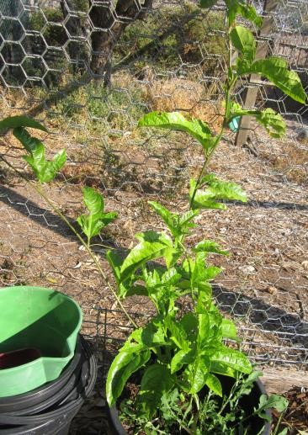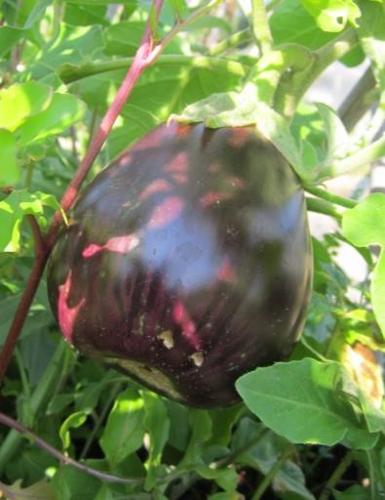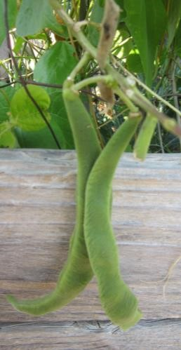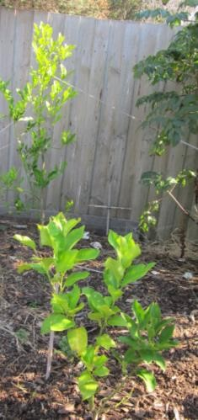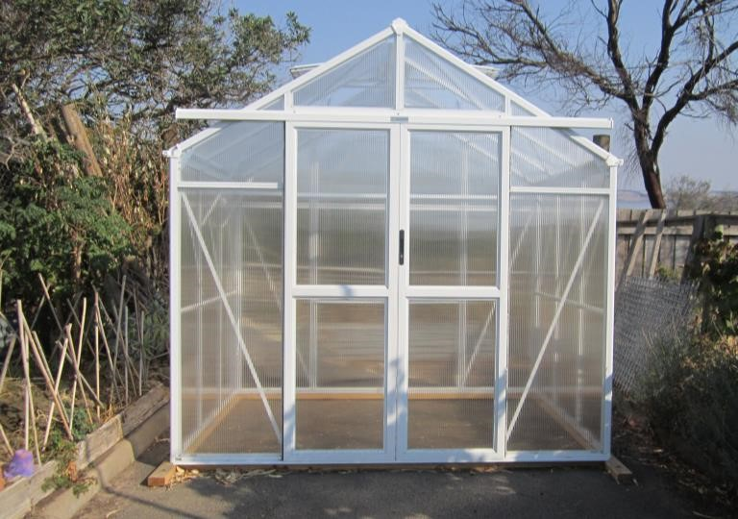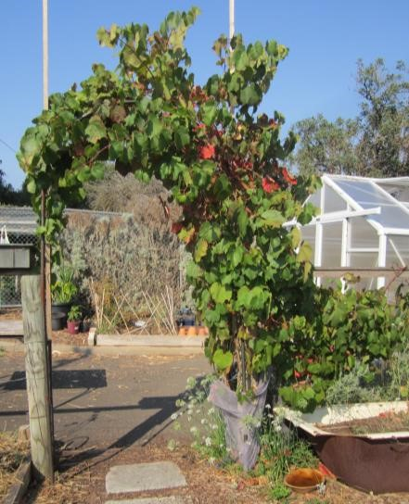

Tides of Welcome Choir Report
In 2018 the Tides of Welcome Choir celebrated 16 years of singing. They were privileged to be involved in the world premier live performance of Gurrumul's Djarimirri (Child of the Rainbow) album at the Queenscliff Music Festival. It was performed with a 16-piece orchestra from the Australian National Academy of Music and was an amazing experience for all involved.
The choir also spent many hours recording some of their songs with the assistance of Nick Huggins and Choir Director, Andrea Robertson and sang at the City of Greater Geelong’s Mountain to Mouth Arts Event. 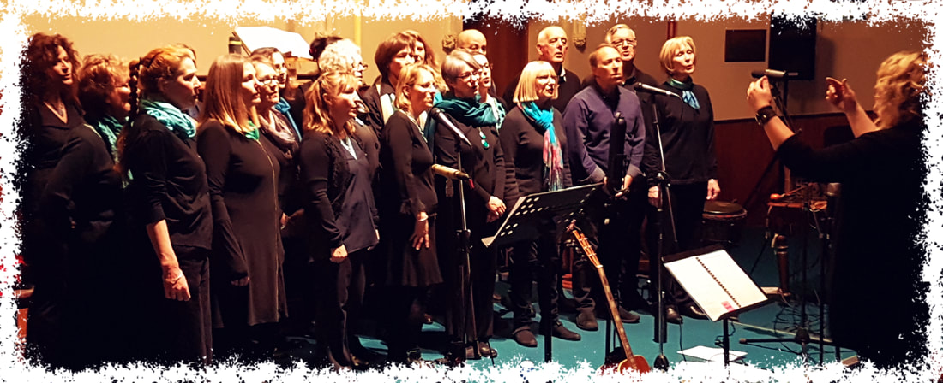
Have a look at their website: http://tidesofwelcome.weebly.com/

Queenscliffe and District Men’s Shed Report, 2018
Now in its 8th year the Men’s Shed continues to operate successfully and provides a range of opportunities and services to its members and the community.
Thursday attendances maintain strong numbers of 25+ while the bikies group meet on Tuesdays as well with regularly about one third of that total. The very affordable membership has been maintained at $15 per year while members contribute $2 weekly to cover costs of tea/coffee/ biscuits and contribute to the power costs of the Neighbourhood House.
A weekly newsletter is written listing those in attendance, activities completed and any notices members need to be alerted to. It is then emailed to the members and friends list and is an important means of keeping everyone informed.
We continue to offer the opportunity for members to complete their own projects, assist with community requests, or merely come and have a chat in a welcoming environment.
The list below provides a snapshot of the range of our last 12months activities.
- Ran BBQ for Neighbourhood House Sand sculpture competition.
- New roof constructed by members for the memorial gazebo at Queenscliff PS.
- Vegie garden production all year round with a range of produce.
- 14 marker posts produced for the borough
- Paper work for bike liabilities completed
- Shed doors constructed at primary school for bike storage
- One member completed first aid course offered by Neighbourhood House
- Dust extractor unit upgraded in the shed at a cost of $610
- Donation of $1000 made to Cottage by The Sea
- Christmas lunch held at Neighbourhood House with partners attending.
- Suggestion box for Neighbourhood House constructed
- Members continue to mow lawns and assist with maintaining gardens for N H.
- Another batch of 100 boomerangs made for local Reconciliation group
- Art gallery display boxes re painted
- Test and tag completed for all our electrical equipment
- Donation of $500 made to Bikes for Humanity
- Shelving constructed for Lighthouse Theatre Group
- Monthly BBQs continue to be looked forward to and enjoyed by members
- A trailer has been donated, renovated, registered and protocol for its use established
- Numerous repairs of chairs, toys and furniture have been carried out for members of the public
- At the request of members, a weekly discussion group has been formed and is well supported
- Our group supported a 3-month trial of the Repair Café concept in October, November and December and contributed $200 towards its costs
- An informal committee system was established in 2016 to share the workload and decision making as well as communicate the workings of the shed to more members. This has been recently revised and formalised creating secretary and treasurer’s positions.
The bikies group’s activities have strengthened and expanded during the last 12 months with 3-4 new regulars who attend the Tuesday morning sessions as well as Thursdays. The list below provides an insight into their program.
- Bikes provided for the Diversitat refugee bike education program.
- Excess bikes donated to the Bikes for Humanity program which are shipped to Namibia where local people are trained in bike mechanics and repairs to provide them with employment and skills.
- Children’s bikes repaired and sold through the Uniting Church’s Vestry Shop
- Queenscliff P S has given us access to one of their sheds which provides much appreciated storage space
- Some of the money raised from bike sales will be used to help fund refugee camps organised by Diversitat in Queenscliff.
- 50 bike helmets donated by RACV for the Diversitat bike education program
- Recently there has been discussions re the possibility of extending the carport to provide more protection from the weather in both summer and winter
- The freshly cooked scones/morning tea is a much appreciated and enjoyed feature of Tuesday mornings

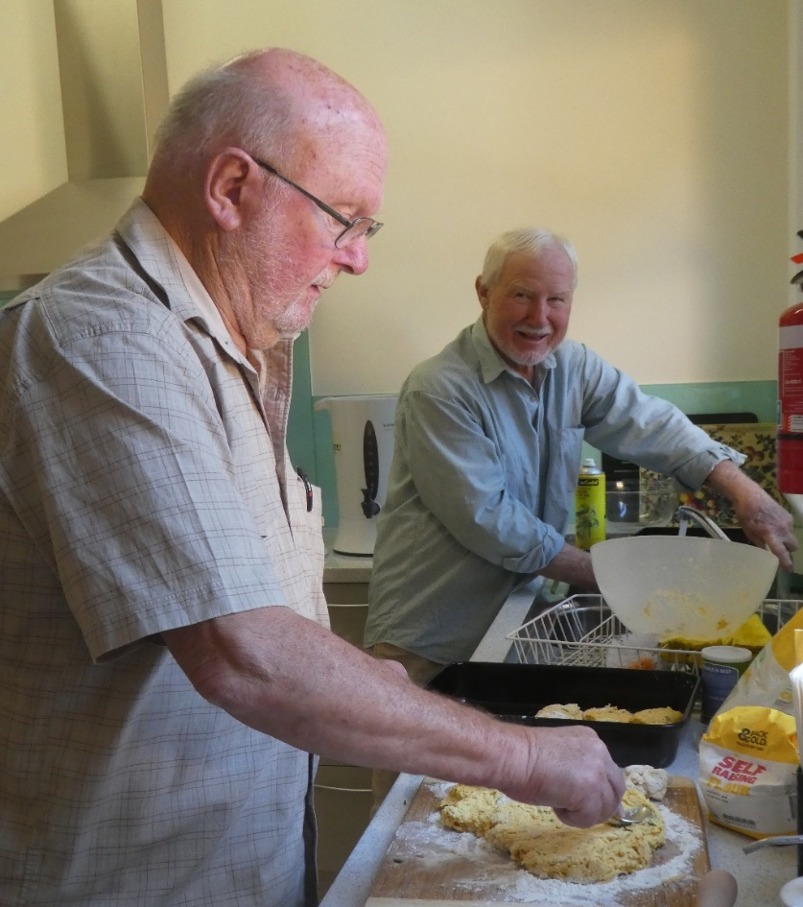
Adrian and Barry in the kitchen
We are grateful for the association which we enjoy with the Queenscliff Neighbourhood House and its coordinator Carolyn Williams which is mutually beneficial to both parties. The shared facilities work well for us and being able to assist with minor maintenance and up keep from time to time is something which we are more than happy to do.
The wider community is now aware of our group and the opportunities it provides for this predominantly retirement population.
We hope to continue to offer a place where men of all ages feel welcome and free to participate in any aspect which interests them.

Les Harrison (for the Queenscliff and District Men’s Shed)

Queenscliffe and District Men’s Shed Treasurer’s report for part financial year to 31 Dec 2018 (Future reporting will be calendar year)

Opening balance at bank as at 01 07 2018 $ 9,472.90
(Opening cash on hand $ 15.00)

INCOME
Member subscriptions 720.00
Sales, projects, surplus tools 360.00
Sales Bikes, repairs 2,350.00
Canteen income 1,657.37
Donation 60.00
QMF payment 500.00

Total $ 5,647.37 $ 5,647.37

$ 15,120.27

EXPENSES
Affiliation expenses (VMSA ) ( Repair Cafe ) 135.35
Purchase tools and materials, general 111.60
Trailer Renovation 340.25
Amenity payments to Q & D N/House. @ $1.00 702.00
Charity donation Bikes for Humanity 500.00
Sponsor Sustainability Living Show 200.00
Test and Tag 320.75
Christmas and BBQ 290.00
Venue Hire XMAS 80.00
Total $ 2,679.95
$ 2,679.95

$ 12,440.32

Less unpresented cheque 290.00

Cash at bank at 31 Dec 2018 $ 12,150.32
(Cash on hand at 31 12 18 $154.15 plus $15 subs carry over) $ 154.15
Financial position as at 31 Dec 2018 $ 12,304.47

50% of weekly attendance and amenities fee of $2.00
per member per visit is paid to Neighbourhood House
on a regular basis and is $702.00 shown above.

John Goodman, Treasurer 10 Jan 2019
Financial Report 2018
Our finances are now budgeted and reported on a Calendar year and not a financial year and as part of this process we refined our reporting categories. Therefore, we do not have direct comparisons for some of the House overhead spending groups eg Utilities & Compliance are part of General Admin in 2017. Overall we can still say that 2018 was a more successful year than 2017!
2018 was a slightly better than “breakeven” year ie the income coming into the House of $157,514 was sufficient to cover the spending on running activities of $63,740 and general overheads of $92,821 for the year.
This is a better result than for the calendar year 2017 - a deficit of $(19,124). This difference is due partly to an increase in funding of 5 hours per week from July 2018, which we directed to a net increase of 3 hours for the Friday office role. This partly compensated the House for the 2 hours paid to our Co-ordinator above the previous Grant funding, leaving a small “surplus” to contribute to general overheads. ($69,890 grant compared to $68,450 employment costs).
Course income also grew from 2017 up to $49,396 from $44,652 in 2017and continued to cover its direct tutor costs. Courses left a margin of $2,520 to help cover the House overheads in 2018. Choir and Ukulele are growing in popularity and contribute a net $3030 to House overheads, up from $2,500 in 2017.
Another growing source of income for the House is room hire which has doubled from 2017. Total spending on administration & marketing in 2018 was $15,313 marginally higher than in 2017.
Less was spent on property and asset maintenance in 2018 - 70% of the spend for the year before when we upgraded blinds, bought the new safe, mower and chairs. Depreciation was also greater in 2017 due to writing off of assets that were no longer being used in the House.
LIQUIDITY
As at December 31st each year QNH has maintained a constant net asset position of around the $70k mark. Although the bank balances look healthier in 2018 compared to 2017, this is because the DHHS grant for Q1 2019 came in December 2018 instead of January 2019, therefore $20,128 is sitting in prepaid grants. Given the deficit for 2017 it is prudent to carry generous reserves, particularly as the House is reliant on Government funds for employment of staff.
NOTE: The 2017 calendar year deficit can be seen in the change in the net asset position in 2017. On January 1st 2017 net assets were $102,400 and this fell to $69,106 at 31 December 2017.
Sue White
QNH Bookkeeper
QNH 2019 Current
Balance Sheet
As of December 2018
 | 31 Dec 2018 |  | $43,100
ASSETS
CURRENT ASSETS
Cash & Investment Accounts
Operating Acct #121700157 | $37,796 |  | $21,770
Cash Floats | $600 |  | $350
TD 'A' General Reserve | $36,168 |  | $35,250
TD 'B' Staff Provisions | $17,912 |  | $17,533
Sandhurst Trustees Investment | $10,319 |  | $10,092
Total Cash | $102,796 |  | $84,995
Debtors & Receivables
Expenses paid in advance for the next year | $414 |  | $96
Debtors | $0 |  | $115
Total Receivables | $414 |  | $211
Total CURRENT ASSETS | $103,210 |  | $85,205
NON CURRENT ASSETS
Solar Panels at cost | $6,568 |  | $6,568
Less Accum Depn Solar Panels | ($4,271) |  | ($2,956)
Office Equipment | $2,781 |  | $6,157
Less Accum Dep office equip | ($802) |  | ($4,311)
Total NON CURRENT ASSETS | $4,275 |  | $5,459
TOTAL ASSETS | $107,485 |  | $90,664
LIABILITIES
Creditors & Payables
Trade Creditors | $59 |  | $479
BB Credit Card | $701 |  | $238
Grants received for the following year | $21,989 |  | $1,271
Total Creditors & Payables | $22,748 |  | $1,988
Payroll Liabilities
Superannuation | $2,614 |  | $4,295
Annual & Long Service Leave Provision | $5,562 |  | $12,354
Total Payroll Liabilities | $8,176 |  | $16,649
BAS Liability
Net GST | $3,420 |  | $486
PAYGW | $2,882 |  | $2,434
Total BAS Liability | $6,302 |  | $2,920
TOTAL LIABILTIES | $37,226 |  | $21,557
NET ASSETS | $70,260 |  | $69,107
QNH 2019 Current
Profit & Loss Statement
 | cy 2018 |  | cy 2017
Income
Government Operating Grants | $69,890 |  | $56,474
Course & Workshop Income | $50,040 |  | $44,652
Fundraising Income | $2,868 |  | $4,962
Choir & Ukulele Income | $18,568 |  | $13,963
Gallery Income | $252 |  | $333
Community Garden Income | $140 |  | $0
House Services Income | $9,516 |  | $10,161
House Rental income | $4,715 |  | $2,385
Investment Income | $1,524 |  | $1,165
Total Income | $157,514 |  | $134,096
Cost Of Services
Course & Workshop Expenses | $46,876 |  | $41,685
Fundraising Costs | $829 |  | $2,275
Choir & Ukulele Expenses | $15,533 |  | $11,378
Gallery Expenses | $445 |  | $0
Community Garden Expenses | $57 |  | $0
Total Cost Of Sales | $63,740 |  | $55,337
Contribution Margin | $93,774 |  | $78,759
House Overheads
Administrative Employ Costs | $68,450 |  | $65,781
Marketing Costs | $2,120
Utilities & Communications | $2,584
Office & General Administratio | $7,522 |  | $14,542
Compliance & Risk Management | $2,216
Financial Expenses | $871
Property & Asset Maintenance | $7,006 |  | $10,072
Depreciation | $2,052 |  | $7,488
Total Overheads | $92,821 |  | $97,883
House Operating Profit | $953 |  | ($19,124)
Grant Income
BOQ - Knitting Grant | $685
QPLCE - Cabinet & Vis Vest | $295
BOQ - Boomerang bags | $1,740
BOQ - Partitions | $1,240
QPLC - Greenhouse Grant | $1,800
 | $5,760
Grant Expenditure
BOQ - Knitting Grant | $686
QPLCE - Cabinet & Vis Vest | $275
BOQ - Boomerang Bags | $1,738
BOQ - Partitions | $1,240
QPLC - Greenhouse Grant spend | $1,800
 | $5,739
Total Surplus/Deficit | $974 |  | ($19,124)

