Queenscliffe and District Neighbourhood House
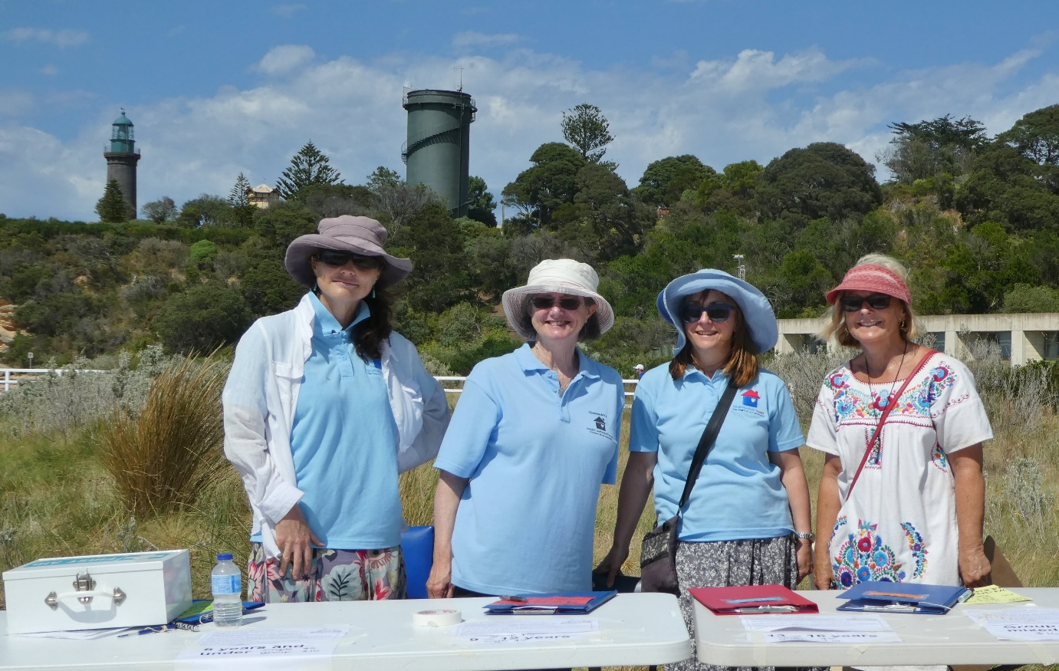
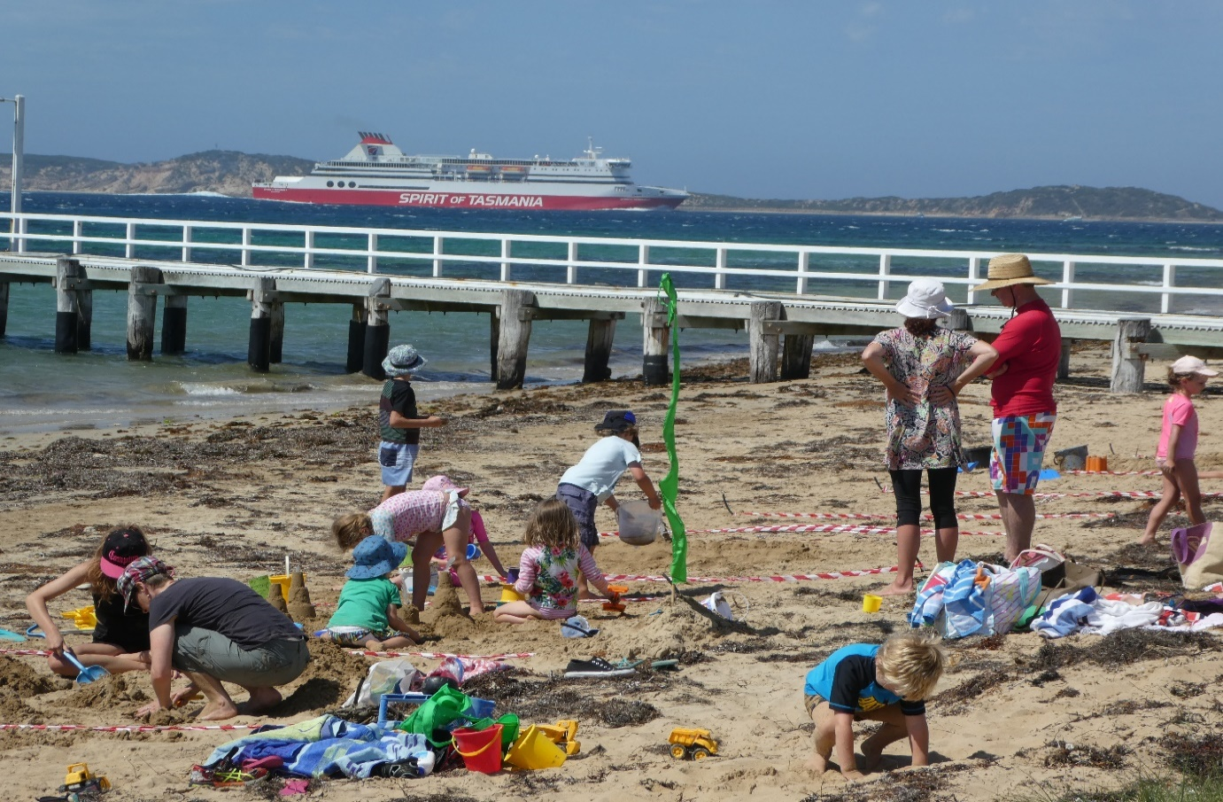
Annual Report 2017
Queenscliffe and District Neighbourhood House
Inc. No. A0009668N ABN: 65 700 715 581
3 Tobin Drive Queenscliff 3225
Phone: 5258 3367
qnhouse@fastmail.fm
www.qnh.org.au

Committee of Management
Chairperson Vice Chairperson
Jacinta Farrugia Laurie Muscat
Treasurer
Jane Rodwell
Secretary
Diana Sullivan
General Members
Lillian van Laar
Kathy Lang
Roel Wasterval
Suzanne Cronin
Sue White
Co-ordinator
Carolyn Williams
Aims
- To foster a spirit of unity within the community.
- To provide a centre for activities that will meet the needs of a wide range of community groups.
- To encourage the community to take an active part in organising and implementing activities.
- To create a neighbourhood network as a focal point for exchange and interaction between groups and individuals at the local level.
- To provide support and scope for personal enrichment and involvement for people of all ages and backgrounds.

Chairperson’s Report
2017 has been a significant year for Queenscliff Neighbourhood House in that we have completed our 3-year Strategic Plan cycle, which we began in 2014. In July 2017, we conducted a strategic plan workshop, which was facilitated by Kylie Pollock who works in the field of Community Development. Members of the Committee of Management, as well as a number of tutors and volunteers attended the full day workshop. This workshop provided us with the opportunity to reflect on the last 3 years, celebrate our achievements and develop a plan that will guide our operations for the next 3 years to ensure we strive to achieve a high standard of governance and accountability. This next plan will be finalised in November 2017 but some of the key recommendations include:
- Conducting a community needs analysis and align our existing program to meet identified needs,
- Developing and implementing a comprehensive promotional strategy based on the analysis,
- Developing a priority short, medium and long-term wish list of future infrastructure requirements to guide grant writing, and
- Conducting a skills analysis of Committee of Management members and recruit or co-opt additional members to fill identified gaps.

I would like to thank the Committee of Management not only for their input into the Strategic Plan, but also to each member for their important contribution whether working behind the scenes supporting Finance, IT, Promotions and Governance or being involved in our programs.
Our volunteers continue to be a valuable resource for our House and support a range of activities including: office administration, repairing bikes for refugees, maintenance on our House or various House events. In particular, I would like to acknowledge the work of a number of volunteers who are stepping down from their positions. Felicity McKenzie, Neil Clowes, Janelle Jenkins and Lillian van Laar have all worked tirelessly as volunteers and have been on our Committee of Management - some for many years. Thank you so much for your significant contributions to the success of our House.
I would like to recognise a number of people and organisations for their ongoing support. This includes: the Queenscliffe Borough Council, the numerous range of local agencies and community organisations, our wonderful tutors and to all the participants who have attended either a QNH program or have been part of the many interest groups which are associated with the House. I would also like to thank Jane Rodwell for taking over as Co-ordinator when Carolyn was on long service leave this year. Thank you Jane for moving into this role seamlessly and doing such a professional and competent job.
Finally, on behalf of the Committee of Management, I would like to thank our hardworking coordinator, Carolyn Williams, for her strong commitment to delivering our vision to be “An innovative Neighbourhood House which is responsive to our community needs. Carolyn your warm, creative and efficient approach is greatly appreciated by all our House community. We look forward to supporting you in implementing our new Strategic Plan over the next 3 years.
Jacinta Farrugia

Co-ordinator’s Report
The Queenscliffe Neighbourhood House has enjoyed another year full of variety reflecting the range of interests and needs of our community. Each day feels different, some are noisy, full of conversation and laughter; others are quieter as people concentrate on their learning tasks. The House is many things to many people but always a place that is welcoming, creating a sense of belonging and community.
The Neighbourhood House Committee of Management have continued to show great support and dedication in strengthening the House’s ability to meet its financial, legal and community obligations. We welcomed 3 new committee members who have brought with them highly valued skills in the areas of finance and environment: Sue, Lillian and Roel. We also farewelled other committee members who have moved on to support the local community in other ways: Janelle, Felicity and Neil. In addition to regular meetings the committee have undertaken policy reviews, participated in a strategic planning day and have implemented new employment systems for our tutors.

Jacinta and I have continued to meet with Borough CEO Lenny Jenner and other council officers on an annual basis to discuss ways we can work together and continue to improve our program and facility for the community. We have also initiated an annual get together with the Councillors so they can be better informed about the Neighbourhood House’s role in the community and needs for facility upgrade. We participated in council’s consultation process in preparation for their Community Plan. Our submission proposed upgrading and highlighting the foreshore between the 2 piers to enhance the communities experience of the Neighbourhood House, picnic areas, playground, boardwalk and café.
Our House Gallery continues to grow in interest and sophistication. We have filled all exhibition places for 2018 and have started a list for 2019.In December we ran another popular Christmas Shop in the Gallery stocking a beautiful array of handmade items which members of the community purchased eagerly for Christmas gifts. Many thanks to the House Gallery team for co-ordinating these activities. In September 2016 we were proud to present the inaugural “Head Start Youth Art" Exhibition. Fourteen young emerging artists from the Bellarine Peninsula, between the ages of 14 – 20 years exhibited work that explored the concept of “home”, encouraging artistic interpretation of both the physical and the abstract. Congratulations to Ollie Hodge and Aaron Ford for their work in organising this Exhibition which saw them awarded the Borough of Queenscliffe’s Australia Day Young Citizens of the Year.
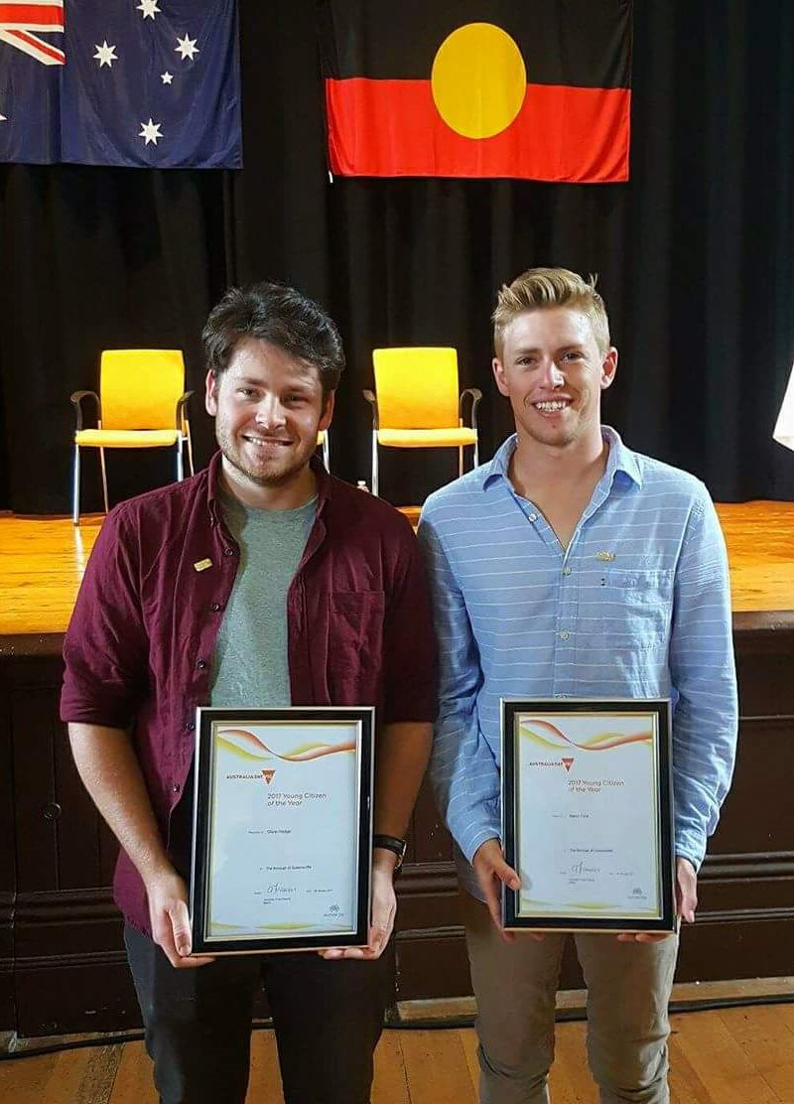

The roll out of the National Broadband Network created much discussion in the community and as a response to this we facilitated several information sessions. Many thanks to Laurie Muscat for his work in running these very well attended forums.
In 2016/17 we also partnered with other organisations:
- Australian Hearing to provide free hearing tests
- The Rotary Club of Norlane’s Road Home Project to collect winter coats and blankets for the homeless – the collection bins were refilled each week through generous community donations
- Leisure Networks to run Tai Chi classes
- The Literary Festival to host 3 workshops including Introduction to Creative Writing convened by our Writers Group
- Ocean Grove Neighbourhood Centre to run a Responsible Service of Alcohol course
- We have been a collection point for 5c coins over $120 has been donated to the Love Your Sister Campaign for cancer research.
- A Bellarine Community Health Centre Grant provided funds to support a very successful series of Healthy Vegan Cooking classes run by the very popular and enthusiastic, Wei Feng
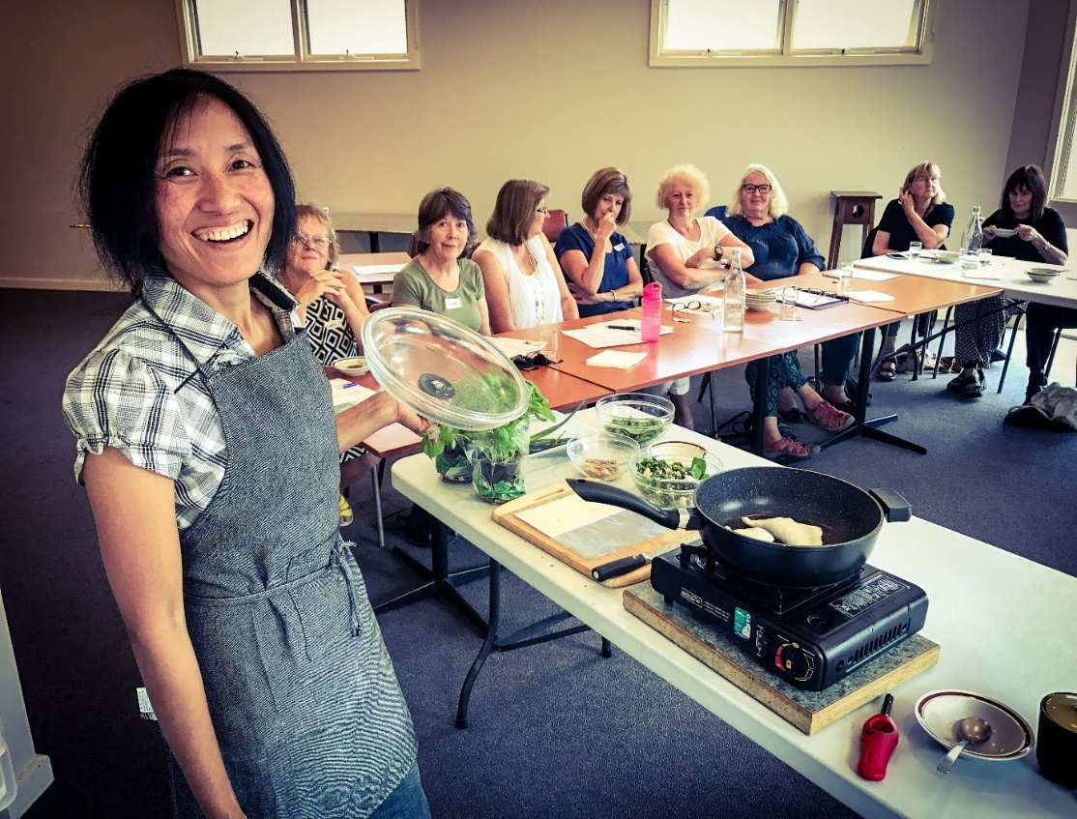

We were also involved with outreach programs to other communities:

- Bicycles were repaired and sent to refugees in Geelong and to African communities via Bikes for Humanity
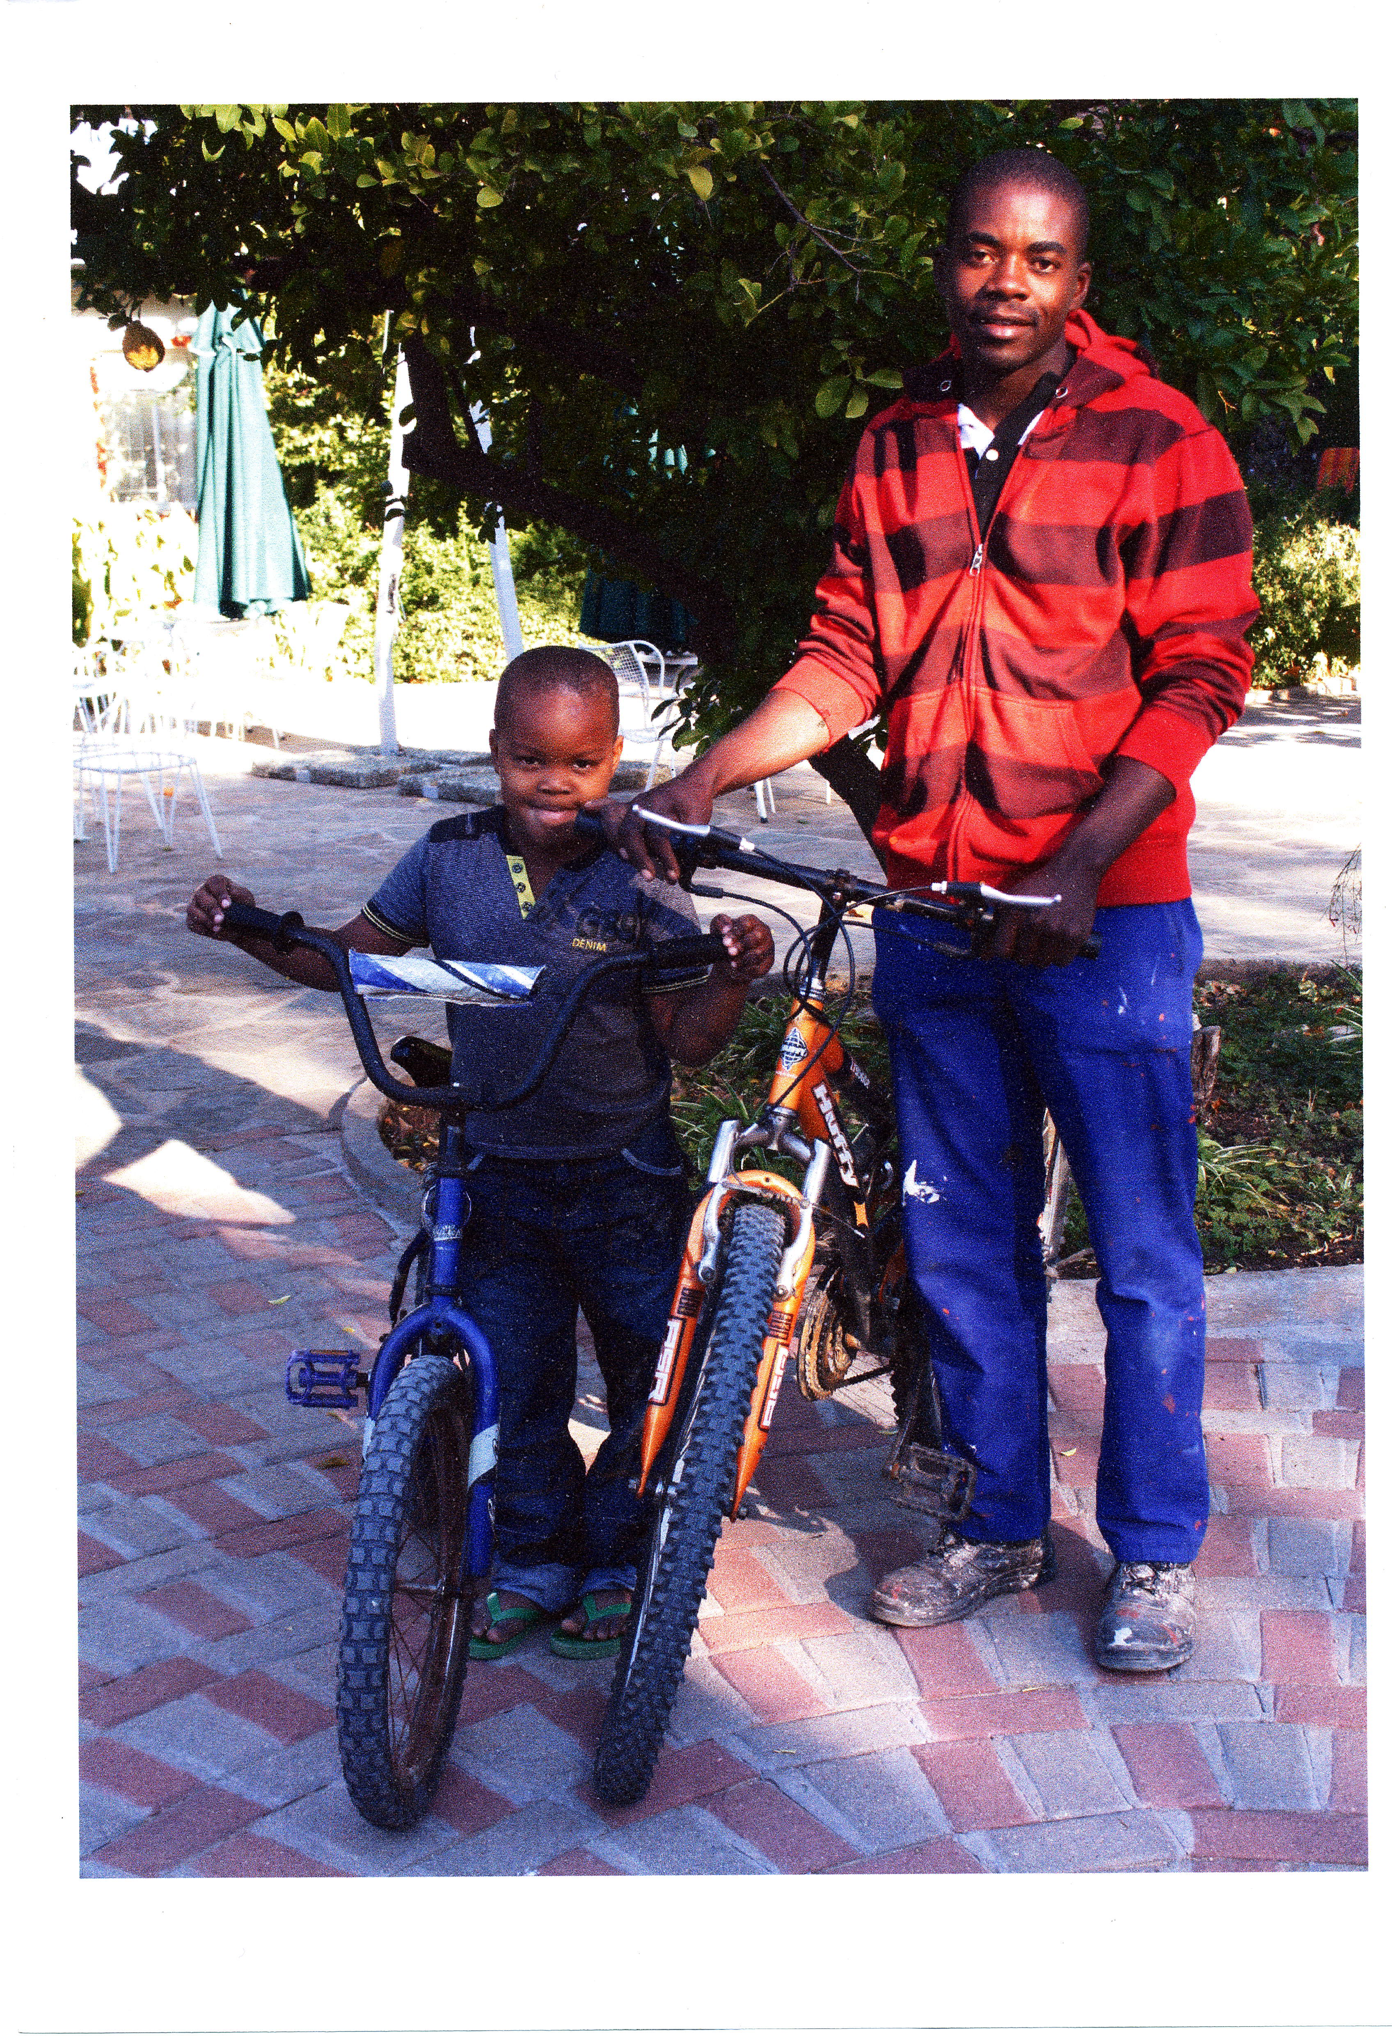
- Sale of bikes supported Queenscliff Uniting Church’s refugee social visits
- Our Mixed Craft Group knitted garments for Cottage by the Sea and Refugees Aid
- Surplus IT equipment was sent to communities in Papua New Guinea
- Chris Gould made 1000 paper doves which were sold as part of our Christmas Shop to raise money for the Asylum Seeker Resource Centre; the dove: symbol of hope, peace, freedom and love.

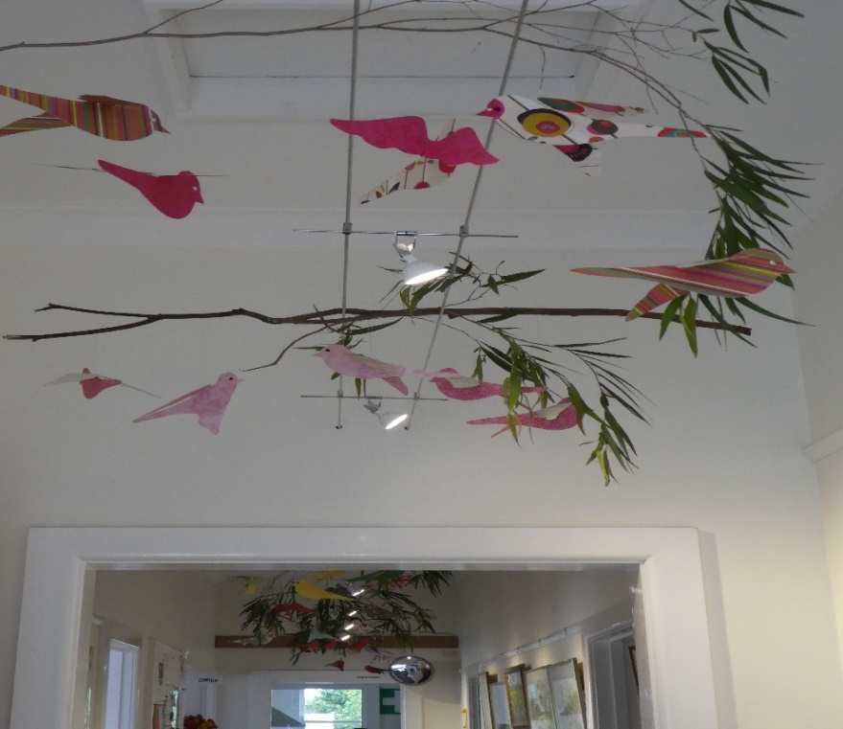

Neighbourhood House groups are also involved with other local organisations:
- The Ukulele Group performed at The Literary Festival
- The Tides of Welcome Choir perform at Queenscliff Music Festival and for the Uniting Church Concert Series
- The Men’s Shed create and repair items for the local schools, Borough of Queenscliffe and RSL

Our relationship with individuals and groups in the community is strengthened and is expanding. I thank everyone who is involved with the House – committee members, office volunteers, event volunteers, Men’s Shed members, tutors, group convenors, participants, local media and the list goes on. We are privileged to live and work in this beautiful area and enjoy the camaraderie we experience working together to maintain a strong and connected community.
Carolyn Williams

Community Garden Report
The new Queenscliff Community Garden subcommittee consisting of Chris, Noelle and Ralph have being working hard to get the garden to be more productive. This includes incorporating community garden beds into the QCG which currently consist of two beds where the strawberry beds were and a bed in the resting chook pen. We have also reworked the raspberry bed which is showing new growth. We have moved the remaining strawberries to one of the baths. Ralph has set up the sink near the main tap & is working on a second set of compost bays in the resting chook pen. Chris has re-established the worm farm in the bath near the tanks and is working on compost areas. Noelle is working on weeding, seed saving and plant propagation. Plus we have extra willing workers in Noelle and Ralph's children. Ralph will coordinate maintenance. Chris will coordinate garden fertility including compost and worms. Noelle will coordinate finances, seed collection and plant propagation. We have plans to establish a bulletin working bees and workshops. In the interim we are working towards getting the garden to bloom. We are establishing a flower bed near the entrance. We have put in lavender cuttings for a lavender hedge along the fence line where the baths are. A passion fruit near the new raspberry bed and plantings in the newly established community plots.
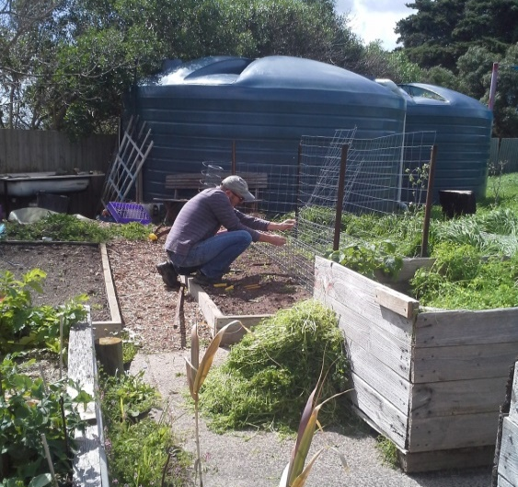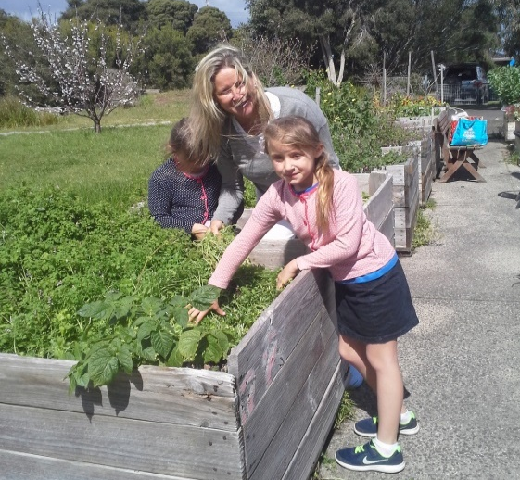
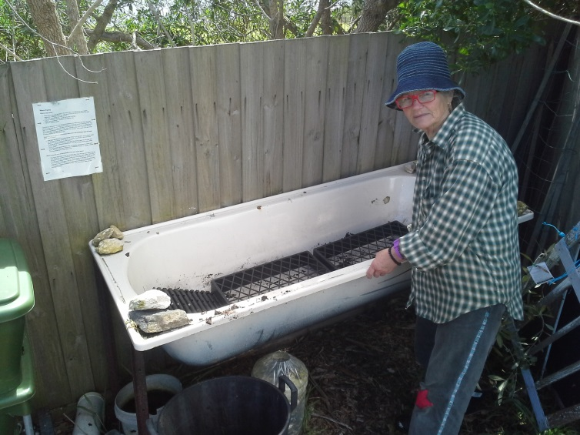
REPORT FROM THE QUEENSCLIFF COMMUNITY GARDEN SUBCOMMITTEE:
Chris, Noelle & Ralph October 2017
Tides of Welcome Choir Report
In 2017 the Tides of Welcome Choir celebrated 14 years of singing Annual performances at the Queenscliff Music Festival and Uniting Church Concert series have enabled the choir to share their warmth, joy and harmonies with audiences and provide polished performances highlighting the various talents of choir members. Have a look at their website: http://tidesofwelcome.weebly.com/

Queenscliffe and District Men's Shed Report
Now in its 7th year the Men’s Shed continues to operate successfully and provides a range of opportunities and services to its members and the community.
Thursday attendances maintain strong numbers of 20+ while the bikies group meet on Tuesdays as well with about one third of that total. The very affordable membership has been maintained at $15 per year while members contribute $2 weekly to cover costs of tea/coffee/ biscuits and contribute to the power costs of the Neighbourhood House.
We continue to offer the opportunity for members to complete their own projects, assist with community requests, or merely come and have a chat in a welcoming environment.
The list below provides a snapshot of the range of our last 12 months activities.
- Ran BBQ for Neighbourhood House Sand sculpture competition.
- Constructed Christmas trees for St. Aloysius Primary School.
- Toy repairs for Ocean Grove kindergarten.
- Vegie garden production all year round.
- Hearing checks conducted by Hearing Australia for 11 members in March.
- Computer information session provided by Telstra.
- Australian flag donated by local member Sarah Henderson.
- Split system air conditioning installed in shed as part of upgrade funded by grant from DHS.
- District men’s shed day at Leopold in October attended by several members with Tony Cooke demonstrating cigar box banjo making.
- Wooden cross constructed for local RSL group for use at Point Lonsdale ANZAC services.
- Christmas lunch held at Neighbourhood House with partners attending.
- Shed made available for art class additional space from time to time.
- Members taking on lawn mowing for N.H. after its purchase of a new mower.
- New metal chiminea purchased and its heat enjoyed by members during the winter months.
- Honour board constructed for Lighthouse Theatre Group.
- Another batch of 100 boomerangs made for local Reconciliation Group.
- An informal committee system was established in 2016 to share the workload and decision making as well as communicate the workings of the shed to more members.
The bikies group’s activities have strengthened and expanded during the last 12 months with 3-4 new regulars who attend the Tuesday morning sessions as well as Thursdays. The list below provides an insight into their program.
  - Bikes provided for the Diversitat refugee bike education program.
  - Excess bikes donated to the Bikes for Humanity program which are shipped to Namibia where local people are trained in bike mechanics and repairs to provide them with employment and skills.
  - Ron North attended Bike Ed training program so he can assist with Diversitat courses.
  - Substantial money from bike sales which will be used to help fund refugee camps organised by Diversitat in Queenscliff.
  - Weather proofing complete with “carport” construction and side blinds.
  - New pressure washer and wheel trimmer purchased.
  - 50 bike helmets purchased for Diversitat program.
  - Involvement in acquiring donated fishing equipment to assist with youth fishing activity run by Diversitat with some members assisting with this program.
  - The freshly cooked scones/ morning tea a much appreciated and enjoyed feature of Tuesdays.
  - Day trip to Cerberus Naval Base near Hastings a much enjoyed bus/ferry trip and day out for bikies.

We are grateful for the association which we enjoy with the Queenscliffe Neighbourhood House and its coordinator Carolyn Williams which is mutually beneficial to both parties. The shared facilities work well for us and being able to assist with minor maintenance and up keep from time to time is something which we are more than happy to do.
The wider community is now aware of our group and the opportunities it provides for this predominantly retirement population.
We hope to continue to offer a place where men of all ages feel welcome and free to participate in any aspect which interests them.
Les Harrison

Treasurers report to: Queenscliff and District Neighbourhood House for financial year 2016/2017

From Queenscliffe and District Men’s Shed.

Opening balance at bank as at 01 07 2016 $6,810.50
(Opening cash on hand $ 102.00)

INCOME
Member subscriptions $ 470.00
Reconciliation mob $ 300.00
Sales, projects, surplus tools $ 266.18
Sales Bikes, repairs $ 3,505.00
Canteen income $ 2,012.70
Final building grant payment $ 2,332.28
$ 4,578.88
Total $ 8,886.16 $ 8,886.16
ADD $15,696.66

EXPENSES
Affiliation expenses (VMSA ) ) $ 50.00
Purchase tools and materials, general $ 1,412.29
Building improvements $ 2,640.00
Purchase Bike parts and tools $ 1,392.04
Ferry and refugee weekend $ 628.00
Amenity payments to Q & D N/House. $1.00 $ 1,538.00
Christmas function $ 129.48
Opening cash $102.00 less closing cash $51.82 $ 50.18

Total $7,839.99 $7,839.99

SUBTRACT $7,856.67

Cash at bank and closing balance for 2016/17 $7,856.67

(Cash on hand at 01 07 2017 $51.82)

50% of weekly attendance and amenities fee of $2.00
per member per visit is paid to Neighbourhood House
on a regular basis and is $1538.00 shown above.

John Goodman , Treasurer 13 July 2017
Tutors
The Neighbourhood House Community Education Program depends on the time and effort of the tutors. Some of these tutors volunteer their time completely, others volunteer their preparation and travel time and are paid at a “community rate”. We thank all our tutors for their efforts and the high quality of their teaching.
Andrea Robertson Tides of Welcome Community Choir
Bruce Sherriff Yoga
Chris Gould Painting Together
David Nash Soft Pastel Painting
David Robertson Djembe Drumming
Deb Brearley Blue Printing (Cyanotype)
Screen Printing
Eve Kelly Yoga
Jane Rodwell and Jenny Gore Play Ukulele
Judy Hassell The Easy, Everyday Vegan
Laurie Muscat Computer Help
Liz Bowman Fermenting Workshop
Louise Stanley Italian & French
Monica Heathcote Crochet
Paul Jones Apple Mac, iPad and iPhone courses
Ryan Brearley Art classes
Shane O Cleirigh Yoga
Shirley Hurley Life Drawing
Silvana Benacchio Mandala Writing and
Peace Cranes for Peace
Sue Simpson Tai Chi – Qui Gong

Tobi Em Make up for the Mature Woman
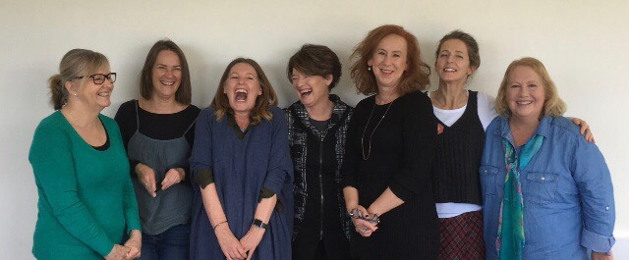
Toni-Anne Levingston Moroccan Cooking Demonstrations
Tony Cook Kitchen Tricks for Men
Wei Feng Healthy Eating Vegan Cooking Demonstrations

We especially want to thank Ryan Brearley for his excellent work as Art Tutor and House Gallery Committee member. Ryan has worked many unpaid hours to support the Gallery in setting up the Youth Art Exhibition and advising new exhibitors on how to present their artwork. We are full of admiration for Ryan’s ability to inspire his class participants to produce fantastic pieces of work and the confidence to share this work with others in weekly appraisals and an annual exhibition. Our Neighbourhood House has become widely known for the interesting and diverse Art classes that change each term and in the past year have included:
Ink Drawing and Painting
Positives and Negatives in Art
The Craft of Art
Painting the Landscape
Apply Colour
Drawing
Draw Paint Print
The Craft of Painting
The Portrait
Soft Pastel Painting

Ryan also organized local artists, Lyn Pring, David Nash, Wendy Naylor, Cathy McCall and Deb Brearley to run an Open Studio and Exhibition in the Neighbourhood House in January. This provided a fantastic opportunity for visitors to view finished pieces in the Gallery and then to observe the artists at work in the front room:
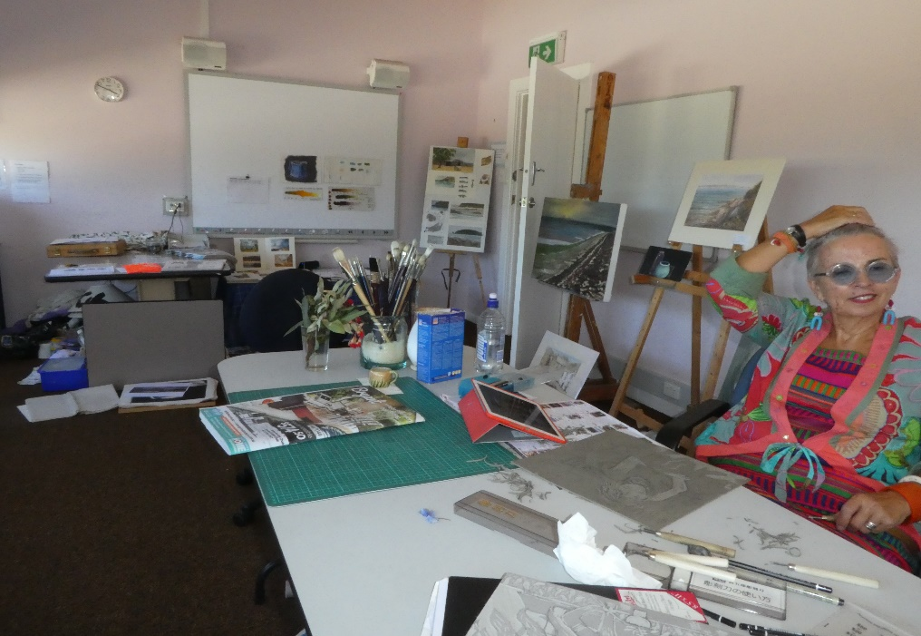
The Open Studio.

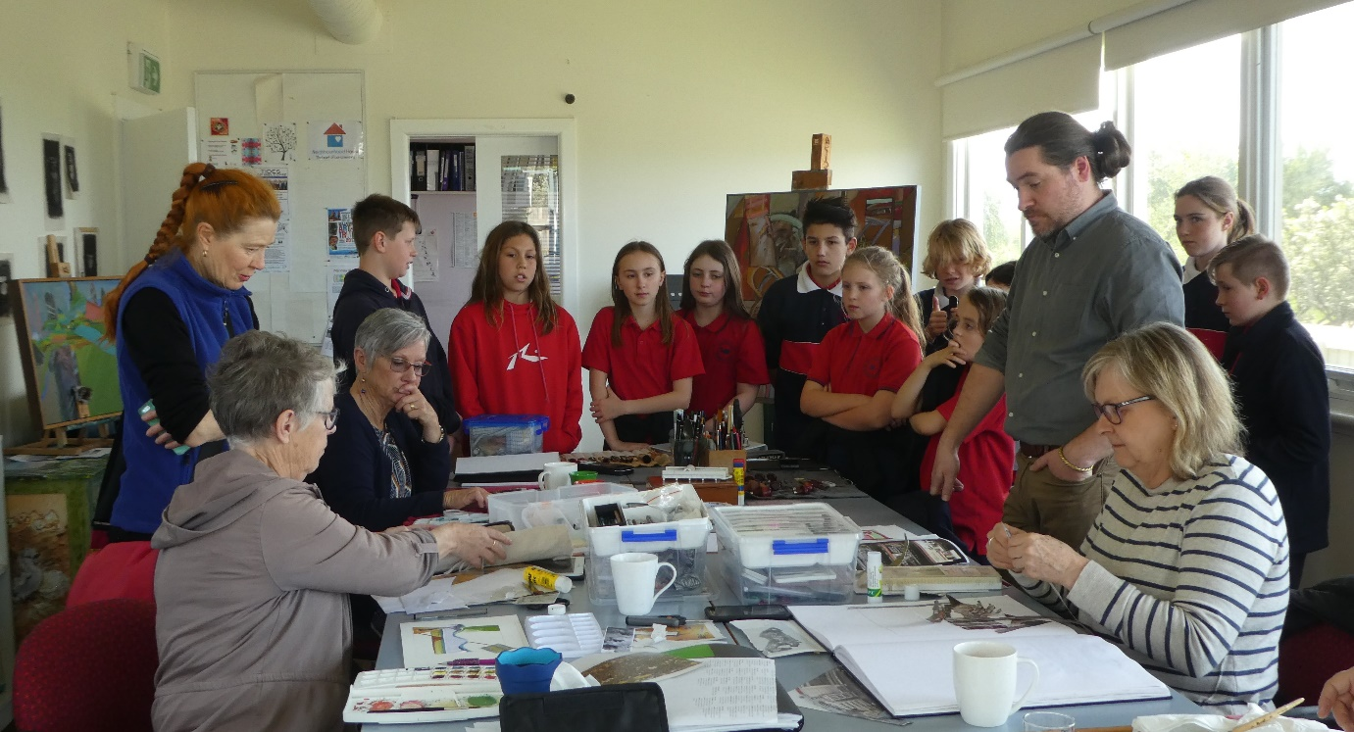
Queenscliff Primary school incorporated a visit to the House Gallery and our Art classes as part of their Art Appreciation Program.
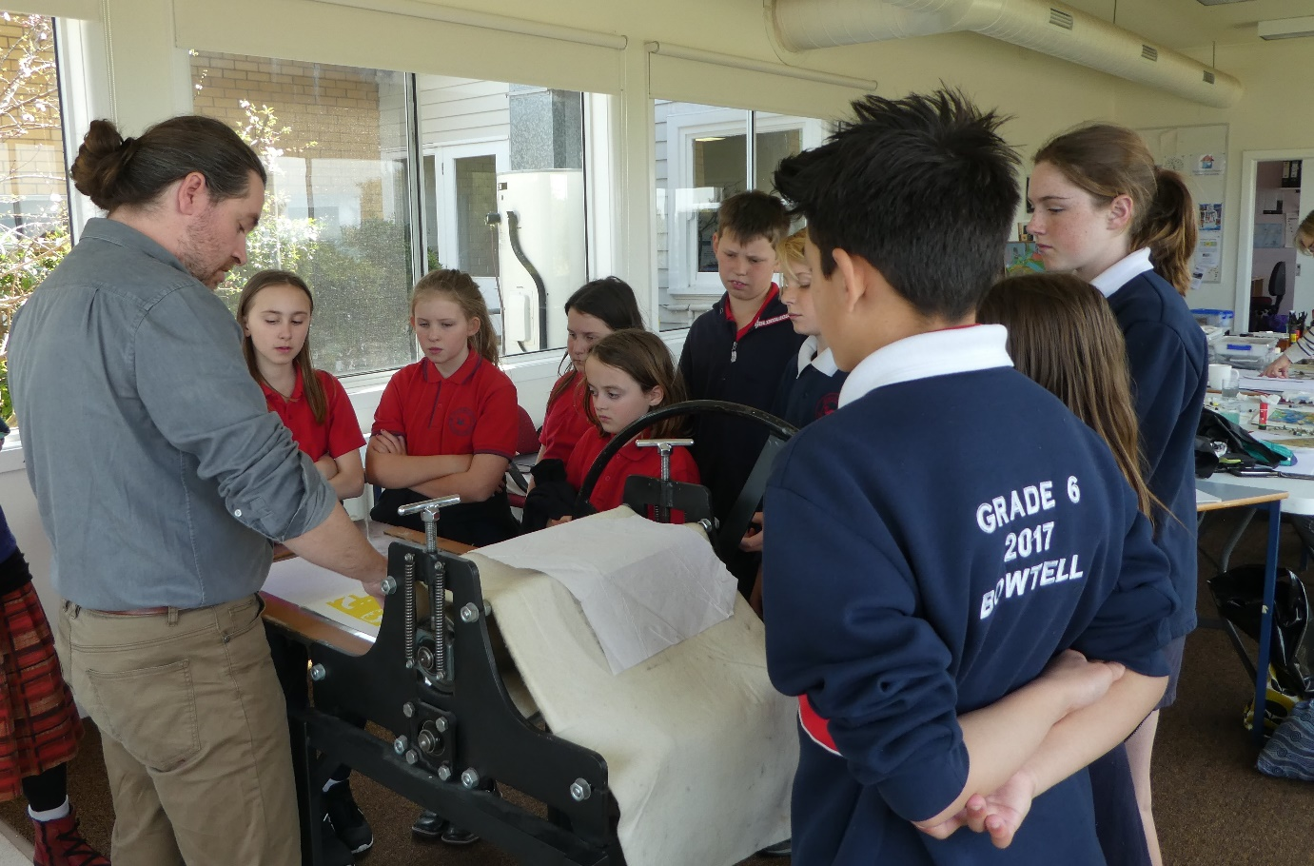
The children were fascinated by the printing press.

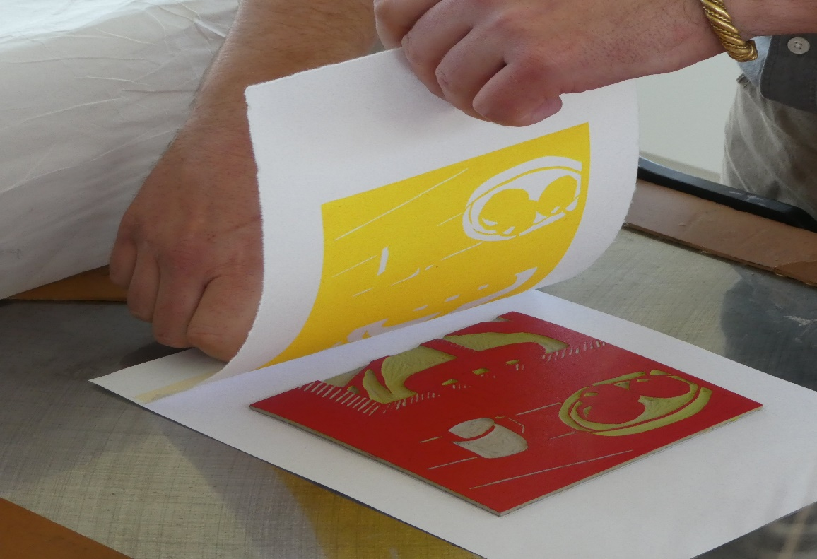

Volunteers
Thank you to all of our volunteers. Your efforts are highly valued and greatly appreciated. We look forward to your continued support.
Office Volunteers:
Trish Miller Judy McKay Leonie Anderson Jo Fearon Tracy Watt
Christine Comiskey Sandra Kent Judith Spittle
Lorraine MacDonald

Finances
Jane Rodwell
Sue White
Lillian van Laar
Terry Philp

Computer Maintenance
Laurie Muscat

Garden
Kevin Fletcher and the Men’s Shed

House Gallery Committee members
Ryan Brearley
Cath McCall
Helen Stillwell
Ollie Hodge
Aaron Ford
Harley Olsen

Community Garden Committee Members
Noell Roob
Ralph Roob
Chris Cherry

Tides of Welcome Committee Members
Paul Jones
Deb Lockie
Alastair McCallum
Rose Ott
Carolyn Williams

Our Interest Group Convenors:
- Photographic Group: Jim Thyer
- Patchwork Network: Gayle Harrell
- Life Drawing: Shirley Hurley and Gail Martin
- Philosophy Circle: Phil Grano
- Mahjong : Gail Stocker
- Mixed Craft Group: Gwen Wren

The Monday Mixed Craft group is thrilled to have been awarded a $1000 grant from the Borough of Queenscliff (2017/18 financial year). This will enable us to purchase yarn to continue to knit and crochet for various organisations in our region.
We provide beanies, slippers and rugs for the children who come to Cottage by the Sea. Knitted bears for children who are sick and in traumatic situations, hats for premmie babies, blankets for humidi-cribs and beanies for refugees are also among the things we make. In addition we make a variety of garments and blankets for Geelong Mums.
All of us do this because we enjoy it and find it therapeutic, we love the company and companionship we get from likeminded people and the sharing of ideas, patterns etc.
Included is a picture of the group at work – so many conversation happening! And some of our products.
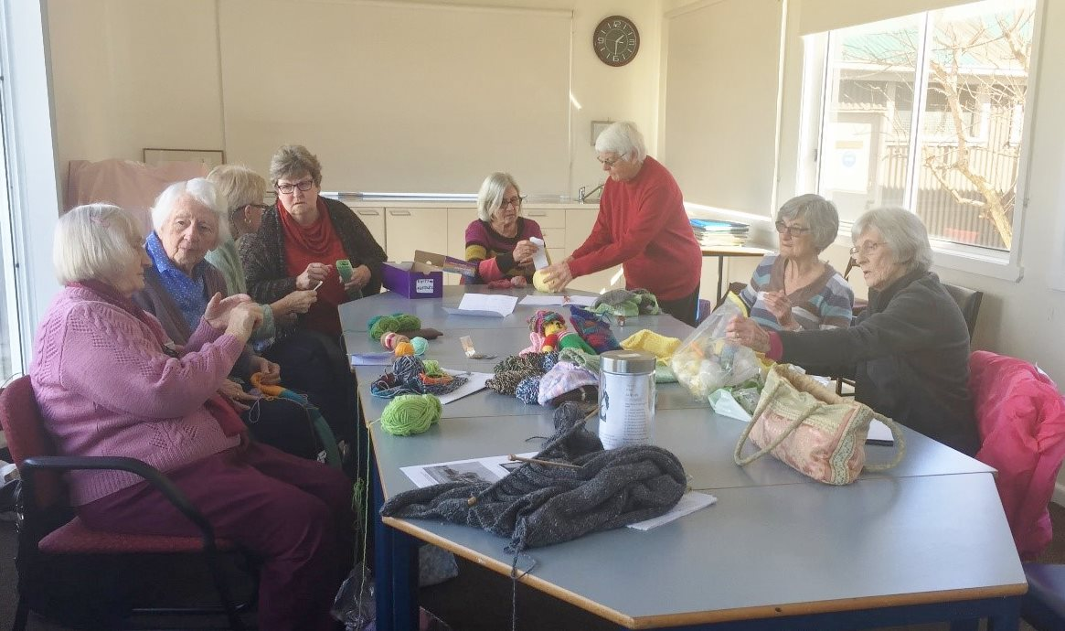

- Queenscliff/Pt Lonsdale Men’s Shed: John Goodman, Ron North
- Friday Painters: Jo Fearon
- Stitchers at Sea: Meralyn Roberts
- Writers Group: Denise Main
- Tides of Welcome Choir: Carolyn Williams

Sand Sculpture Contest Judges:
Shirley Hurley, Sally Rodwell, Beth Hodge, Kate Parton, Steve Parkhill
Fundraising and Event Support:
Vicki Green, Paul Jones, Judith Spittle, Amanda Hurst, Dennis Farrugia, Roel Wasterval, Lillian van Laar, Sue White, Jacinta Farrugia, Janelle Jenkins, Jane Rodwell, Kathy Lang, Felicity McKenzie, Neil Clowes, Tony Cook and the Men’s Shed team, Laurie Muscat, Shona Murray, Pauline Nunnan, Allan Johns and Diana Sullivan
Financial Sponsors: Queenscliff Bowling, Tennis and Croquet Club, Queenscliff Foodworks, Fletcher’s Real Estate, QPLCE and 360Q.
Contest Prize Donors: Marine Discovery Centre, Queenscliff Bookshop, Sea Road Ferries, Lix Ice-Cream, Queenscliff Bowling Club,
Advertising: Queenscliffe Herald, The Rip, The echo, Bellarine Times and The Advertiser
Financial Support
We remain grateful to the Victorian State Government in providing Co-ordination funding through the Department of Health and Human Services.
Other funds received include:
$5270 Bellarine Community Health Centre Grant to run Healthy Eating Vegan
Cooking Demonstrations

$3635 QPLCE Grant to purchase P.A. equipment
$2240 Donation from Queenscliff Community Market to support Inaugural Head
Start Youth Art Exhibition

$ 500 Borough of Queenscliffe to support Open Day activities

Financial Report 2017
